**Aim: Program to simulate traffic between two nodes.**

**Code:**

#include "ns3/applications-module.h" #include "ns3/core-module.h" #include "ns3/internet-module.h"

#include "ns3/network-module.h" using namespace ns3;

NS_LOG_COMPONENT_DEFINE("FirstScriptExample"); int

main(int argc, char* argv[])

{

CommandLine cmd( FILE ); cmd.Parse(argc, argv); Time::SetResolution(Time::NS);

LogComponentEnable("UdpEchoClientApplication", LOG_LEVEL_INFO); LogComponentEnable("UdpEchoServerApplication", LOG_LEVEL_INFO); NodeContainer nodes;

nodes.Create(2); PointToPointHelper pointToPoint;

pointToPoint.SetDeviceAttribute("DataRate", StringValue("5Mbps")); pointToPoint.SetChannelAttribute("Delay", StringValue("2ms")); NetDeviceContainer devices;

devices = pointToPoint.Install(nodes); InternetStackHelper stack; stack.Install(nodes); Ipv4AddressHelper address;

address.SetBase("192.168.1.0", "255.255.255.0");

Ipv4InterfaceContainer interfaces = address.Assign(devices); UdpEchoServerHelper echoServer(9);

ApplicationContainer serverApps = echoServer.Install(nodes.Get(1)); serverApps.Start(Seconds(1.0));

serverApps.Stop(Seconds(10.0));

UdpEchoClientHelper echoClient(interfaces.GetAddress(1), 9); echoClient.SetAttribute("MaxPackets", UintegerValue(1)); echoClient.SetAttribute("Interval", TimeValue(Seconds(1.0))); echoClient.SetAttribute("PacketSize", UintegerValue(1024)); ApplicationContainer clientApps = echoClient.Install(nodes.Get(0)); clientApps.Start(Seconds(2.0));

clientApps.Stop(Seconds(10.0)); Simulator::Run(); Simulator::Destroy();

return 0;

}

**Output:**

Step1: open example folder

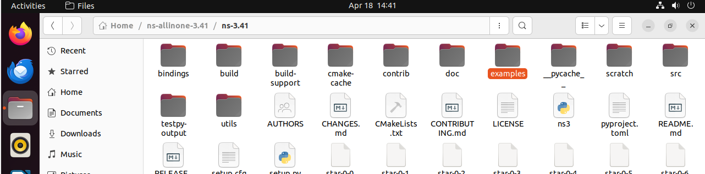

Step2: copy the first.cc file

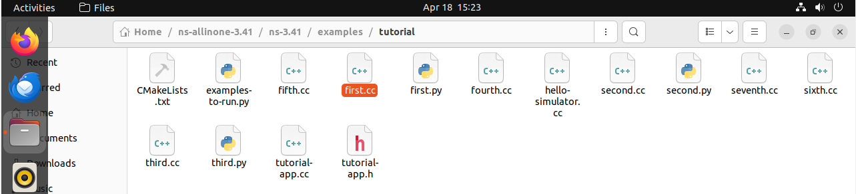

Step3: come back to ns-3.41 and open scratch folder

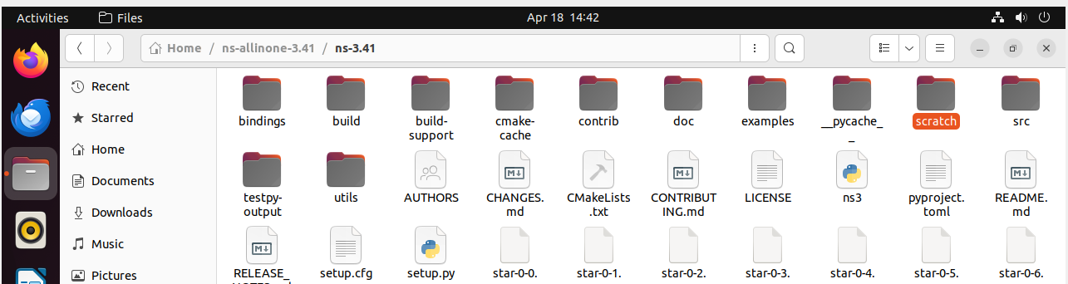

Step4:  Paste the first.cc file here

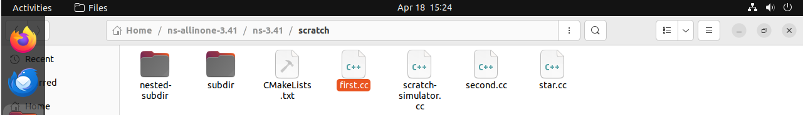

Step 5: Back to ns-3.41 file click on 3 dot it gives the option for open terminal run the command

./ns3 run scratch/first

